OOP Lab: Experiment 11

Submitted By: Aryan Saxena

Batch: B1

SAP Id: 500082431

Roll No.: R214220274

**Exercise 1:**

## Code:

import java.sql.*;

public class JDBC1

{

    public static void main(String[] args)

    {

        try

        {

            Class.forName("com.mysql.cj.jdbc.Driver");

            Connection con=DriverManager.getConnection("jdbc:mysql://localhost:3306/jdbcass","root","0000");

            Statement stmt = con.createStatement();

            int n = stmt.executeUpdate("create table Employee(Name varchar(255), ID int, Email varchar(255), Number long)");

            String Data="INSERT INTO Employee("

            + "Name, ID, Email, Number) VALUES "

            + "('Aryan', 001, 'ar@gmail.com',9876543210), "

            + "('Arann', 002, 'arr@gmail.com',9876543210), "

            + "('Aryannn', 003, 'arrr@gmail.com',9876543210), "

            + "('Aryannnn', 004, 'arrrr@gmail.com',9876543210);";

            n = stmt.executeUpdate(Data);

            System.out.println("Number of rows updated: "+n);

            con.close();

        }

        catch(Exception e)

        {

            System.out.println(e);

        }

    }

}

## Output:

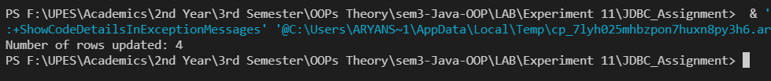

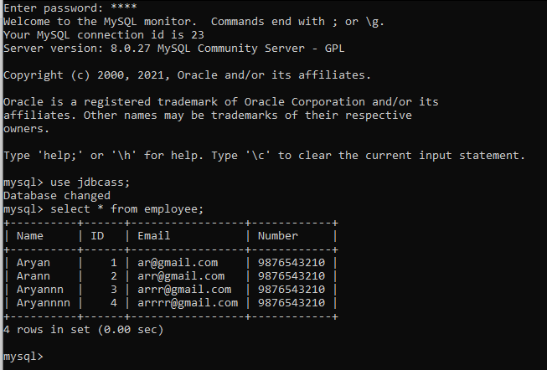

**Exercise 2:**

## Code:

import java.sql.*;

public class JDBC2

{

    public static void main(String[] args)

    {

        try

        {

            Class.forName("com.mysql.cj.jdbc.Driver");

            Connection con=DriverManager.getConnection("jdbc:mysql://localhost:3306/jdbcass","root","0000");

            Statement stmt = con.createStatement();

            int n = stmt.executeUpdate("create table Employee2(Name varchar(255), ID int, Email varchar(255), Number long)");

            String Data="INSERT INTO Employee2("

            + "Name, ID, Email, Number) VALUES"

            + "('Aryan', 001, 'ar@gmail.com',9876543210), "

            + "('Arann', 002, 'arr@gmail.com',9876543211), "

            + "('Aryannn', 003, 'arrr@gmail.com',9876543212), "

            + "('Aryannnn', 004, 'arrrr@gmail.com',9876543213);";

            n = stmt.executeUpdate(Data);

            System.out.println("Number of rows updated: "+n);

            ResultSet rs = stmt.executeQuery("Select * from Employee2");

            while(rs.next())

            {

                System.out.print("Name: " + rs.getString("Name")

                                +"\tID: " + rs.getInt("ID")

                                +"\tE-mail: " + rs.getString("Email")

                                +"\tNumber: " + rs.getLong("Number"));

                System.out.println();

            }

            con.close();

        }

        catch(Exception e)

        {

            System.out.println(e);

        }

    }

}

## Output:

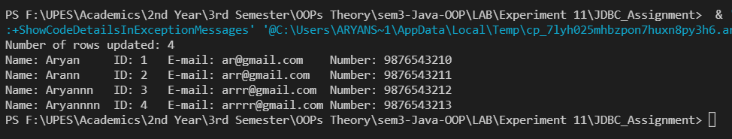

**Exercise 3.i:**

## Code:

**import** java.sql.*;

**public** **class** JDBC3i {

**public** **static** **void** main(String[] args) {

**try**{

Class.*forName*("com.mysql.cj.jdbc.Driver");

Connection con=DriverManager.*getConnection*("jdbc:mysql://localhost:3306/jdbcass","codebind","1417");

Statement stmt=con.createStatement();

//boolean s = stmt.execute("create table MEETING(NameOfParticipant varchar(255),MeetingId int,ScheduleTime varchar(255),Email varchar(255), Mobile long)");

//boolean s = stmt.execute("insert into MEETING(NameOfParticipant,MeetingId,ScheduleTime,Email, Mobile) values('Priyansh',0004,'Tuesday','priyanshkamail@gmail.com',9876543214)");

ResultSet rs = stmt.executeQuery("select*from MEETING WHERE MeetingId = 1114");

**while**(rs.next())

//System.out.println(s);

System.***out***.println("Names with meetingId 1144 : " + rs.getString(1));

con.close();

}**catch**(Exception e){

System.***out***.println(e);

}

}

}

## Output:



**Exercise 3iv:**

## Code:

**import** java.sql.*;

**public** **class** JDBC3iv {

**public** **static** **void** main(String[] args) {

**try**{

Class.*forName*("com.mysql.cj.jdbc.Driver");

Connection con=DriverManager.*getConnection*("jdbc:mysql://localhost:3306/jdbcass","codebind","1417");

Statement stmt=con.createStatement();

ResultSet rs = stmt.executeQuery("select*from MEETING WHERE ScheduleTime = 'Tuesday';");

**while**(rs.next())

System.***out***.println("Participants attending Tuesday meetings: " + rs.getString(1));

con.close();

}**catch**(Exception e){

System.***out***.println(e);

}

}

}

## Output:

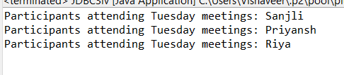

**Exercise 3ii:**

## Code:

**import** java.sql.*;

**public** **class** JDBC3ii

{

**public** **static** **void** main(String[] args)

{

**try**

{

Class.*forName*("com.mysql.cj.jdbc.Driver");

Connection con=DriverManager.*getConnection*("jdbc:mysql://localhost:3306/jdbcass","codebind","1417");

Statement stmt=con.createStatement();

//boolean s = stmt.execute("Create table Partpant3(partpantId int primary key AUTO_INCREMENT, partpantName varchar(255));");

//boolean v = stmt.execute("insert into Partpant3(partpantName) value('Avinash')");

ResultSet rs = stmt.executeQuery("Select*from Partpant3");

**while**(rs.next())

System.***out***.println(rs.getInt(1) + " " + rs.getString(2));

con.close();

}

**catch**(Exception e)

{

System.***out***.println(e);

}

}

}

## Output:

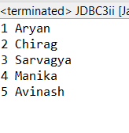

**Exercise 3iii:**

## Code:

**import** java.sql.Connection;

**import** java.sql.DriverManager;

**import** java.sql.ResultSet;

**import** java.sql.Statement;

**public** **class** JDBC3iii

{

**public** **static** **void** main(String[] args)

{

**try**

{

Class.*forName*("com.mysql.cj.jdbc.Driver");

Connection con=DriverManager.*getConnection*("jdbc:mysql://localhost:3306/jdbcass","codebind","1417");

Statement stmt=con.createStatement();

ResultSet rs = stmt.executeQuery(" select COUNT(*) from meeting Where MeetingId = 1114");

**while**(rs.next())

System.***out***.println("Number of Participants with meeting id 1114 : " + rs.getInt(1));

con.close();

}

**catch**(Exception e)

{

System.***out***.println(e);

}

}

}

## Output:

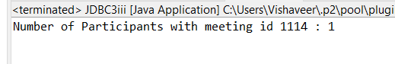

**Exercise 3iv:**

## Code:

import java.sql.*;

public class JDBC3iv {

    public static void main(String[] args) {

        try{

            Class.forName("com.mysql.cj.jdbc.Driver");

            Connection con=DriverManager.getConnection("jdbc:mysql://localhost:3306/jdbcass","root","0000");

            Statement stmt=con.createStatement();

            ResultSet rs = stmt.executeQuery("select*from MEETING WHERE ScheduleTime = 'Tuesday';");

            while(rs.next())

                System.out.println("Participants attending Tuesday meetings: " + rs.getString(1));

            con.close();

        }catch(Exception e){

            System.out.println(e);

            }

    }

}

## Output:

